Land Use Impacts of a Reform of the U.S. Environmental Agency Rule
Associated with Carbon Dioxide Emissions from Processing of Annual Crops

Prepared for the Biogenic CO₂ Coalition

Dermot Hayes
Charles F. Curtiss Distinguished Professor in Agriculture and Life Sciences
Pioneer Chair of Agribusiness
Professor of Economics
Professor of Finance
Iowa State University

Executive Summary
This report evaluates the land use impacts of a reform to the U.S. Environmental Protection Agency’s (EPA), Prevention of Significant Deterioration (PSD) and Nonattainment New Source Review (NSR) permitting programs for CO₂ emissions from the processing of annual crops. The procedure used in this report is exactly that used to derive the original land-use change results in Searchinger et al. First, the projected impact on annual crop use in the US is taken from an earlier analysis of the economic impact of the rule change conducted by the Policy Navigation Group (PNG). These PNG projections are adapted for current circumstance in the US corn processing industry. Second, the dollar investments to build new, or adapt old plants in the PNG analysis are converted into a change in worldwide corn demand using a dry mill ethanol plant as a benchmark. Third, the projected increase in corn demand is input into the economic model used by Searchinger et al. and is shown to increase world corn prices by $0.03 per bushel. This results in a worldwide increase in land use of 24,500 hectares per year, of which 6,363 ha/year would be in Brazil. These impacts are tiny relative to the Searchinger et al. result and should therefore meet any reasonable De Minimis criteria.

Introduction
I have been asked by the Biogenic CO₂ Coalition to estimate the land use impacts of providing relief from including biogenic CO₂ emissions in the Clean Air Act Permitting Programs, specifically those emissions from fermentation of annual crop-derived plant biomass. I am familiar with the economic forces that drive direct and indirect land use change. I am an author on the highly cited Searchinger paper and on two earlier papers that explained the economic modelling and derived key economic results in the Searchinger paper. I, therefore, feel well qualified to provide these calculations.

Economic Forces Driving Land Use Change
In our 2006 and 2007 papers, we estimated the impact of a policy change; a volumetric ethanol excise tax credit (VEETC) of $0.51 per gallon offered to refiners for blending ethanol with gasoline. We then explained that with the ethanol prices current at that time and the tax credit there was arbitrage in US ethanol production because ethanol producers could buy inexpensive corn to produce expensive ethanol. We then predicted the growth in US ethanol production that would be required to drive these arbitrage profits to zero. We calculated that with this additional demand for corn, the world price of corn would increase significantly and that this increase would stimulate additional worldwide corn production. This additional production would come in part from conversion of pasture and forest land into cropland. All the modelling in these two papers was done using the CARD-FAPRI commodity model. The incremental contribution of the Searchinger paper over and above the two earlier papers was to show that if one included the Green House Gases (GHGs) released from this converted land, the environmental benefits of ethanol would be reduced.

Marginal Impact of Policy Changes
The key to understanding the land use impacts in the Searchinger paper is that at the margin, policy changes caused ethanol prices to increase and this in turn caused an increase in world crop land area via high corn prices. To separate out the impact of the policy change, we ran the model to establish a baseline and then ran it again with the VEETC in place. The difference between the two runs was interpreted as the impact of VEETC. Economists use the term ceteris paribus to describe this procedure. It means that the impact of the policy change is evaluated while holding all other variables constant. Following this logic, the land use implications of a change in the way EPA regulates CO₂ emissions from plants that process crop-derived biomass would be to first calculate the impact of the rule change on the processing of annual crops in the US. Second, net out the displacement effect that large new processing facilities will have on smaller facilities and on facilities in other countries. Third, evaluate the net impact on world corn prices. Fourth, use the model underlying Searchinger paper to calculate the impact of an increase in world corn prices on worldwide land use. Note that in the real world, there will be many forces, such as the US trade war with China, and changes in environmental policy in Brazil that drive land use change. These other forces will be excluded from the results using the marginal analysis described above. These forces need to be excluded because they would happen with or without the EPA permitting change.

Prior Economic Work
In 2018, the Policy Navigation Group conducted a detailed economic analysis on the impact of the EPA rule change on the processing of annual crops in the US. The focus of the study was on the economic activity that would be generated by the rule change. The study used a database on NSR applications and the frequency of minor permit applications. The report concluded that for corn processing, the primary effect of the change would be to enable projects that modify existing wet mills to produce bio-products such as bioplastics and biofuels. For other sectors including oilseed processing, fluid milk processing, bakeries and breweries, the impact is due to enabling construction or modification of facilities that were downsized or deferred due to NSR permitting restrictions. They argue that these facilities were often constructed at less than optimal scale to avoid the NSR permitting progress. The conclusion of the report is an annual additional capital investment of $747 million of which $385 to $580 million is for dry and wet mill corn plants and $167 million is for the other impacted sectors.

Current Status of the Wet and Dry Mill Corn Processing Plants
One possible result of the rule change would be to allow for expansion or construction of large-scale corn wet mills or dry corn ethanol plants. It is, therefore, worth asking if there are circumstances where the rule change, on its own, would bring about an expansion of corn processing in the US. In a project I did for the State of Iowa, I surveyed the existing wet corn mills in the state to ask about possible response to a state tax credit. I learned that there is excess capacity to produce corn sweetener in the US due to a reduction in consumer demand.

The owners of these plants were very interested in partnerships to produce advanced bio products that would use this excess sugar. There was no interest in expansion of existing plants. One of the individuals I interviewed,, described the company’s attempts to repurpose a $400 million dollar corn processing facility. It had been completed in 2010 and was seldom at capacity. He also described the company’s intent to find “Over-the-Fence” opportunities. In this business-model, a third party seeking to commercialize new technology would co-locate adjacent to the corn wet milling facilities. Another interviewee, who had 27 years of experience in grain processing, biochemicals and energy, said that Iowa had a huge surplus of industrial sugars such as dextrose, glucose and fructose produced from corn. These products were available from wet mills located in Clinton and Fort Dodge, Iowa and Blair, Nebraska.

The situation for dry corn ethanol plants is even worse. These plants benefited from the 15 billion-gallon RFS mandate up to the point where US ethanol production exceeded the mandate. Once this happened, the excess ethanol was sold based on its energy value relative to gasoline. In a commodity market, if an excess gallon is sold at a discount, then all gallons sold on that day will also sell at the reduced price. Once this happened, the US ethanol industry entered a period of economic decline. Some plants are not even covering their variable costs and many have closed.

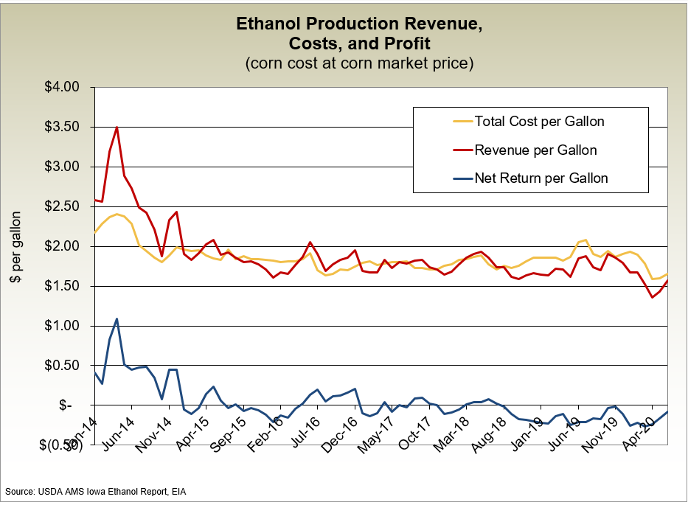

US ethanol production exceeded 15 billion gallons sometime in 2015 and as can be seen from the chart above, the industry has never been profitable on an annual basis since then. As a result, there is no interest in building additional ethanol production capacity in the US. This situation will not change unless the ethanol mandate is increased and there seems little likelihood that this will occur. Even if it did, the EPA would be positioned to evaluate the land use impacts. I can, therefore, rule out any expansion of corn processing in the US. This means that the additional capital investment in corn processing plants identified by the Policy Navigation Group would involve modifications of existing plants to produce bio-products and biochemicals. This would have no impact on US corn demand and can be ruled out as a contributor to land use change.

Other Capital Investments
Of the $167 million in new investment outside of the corn-processing sector identified by the Policy Navigation Group, some of the investment would involve expansion of processing and some would involve modifications of existing plants. Where new plants are constructed to process soybeans or milk, the end-product will be sold as a commodity on the domestic or international market. A portion of any increase in US production due to the construction of larger plants will be offset by reduced growth elsewhere. For breweries and bakeries, the additional production from larger plants will be offset by reductions in output from smaller plants.

The Policy Navigation Group does not provide enough information to calculate the proportion of investments that will lead to additional output versus modifications to additional plants. Nor does it allow me to calculate how much of any additional output will be offset by reductions in output or a reduction in the rate of growth elsewhere. I have conservatively assumed that two thirds of the new investments lead to additional output and that one third of the additional output is offset by reduced production in other countries or from smaller plants in the US. This means that $74 million of the new investment will be in newer plants where output is not offset by a reduction elsewhere.

Next, I need to calculate how much additional demand for annual crops will be generated by an annual investment of $74 million. For this, I use dry corn ethanol as a benchmark. In doing this, I am assuming that each dollar spent on facilities that expand production for annual crops results in the same increase in corn demand as the same dollar spent on new dry mill ethanol facilities. Again, this is conservative because dry mill corn ethanol plants are much less capital intensive per bushel consumed than bakeries, breweries or milk processing facilities.

It costs $2.15 per gallon to build a new dry corn ethanol plant. This means that an annual investment of $74 million would lead to an increase in ethanol production of 34.5 million gallons. If we then assume a corn to ethanol conversion of 2.8 gallons per bushel, then the annual increase in corn consumption is 12 million bushels.

A Comparison with the Searchinger Result
As mentioned earlier, the key economic result in the Searchinger paper was based on an earlier paper by Elobeid et al . This paper used a ten-year partial equilibrium commodity model to predict the market impact of a huge expansion in US ethanol production. The projected expansion caused the US ethanol industry to increase US ethanol production by 56 billion liters or 14.79 billion gallons and corn use by 5.28 billion bushels over a ten-year period. This is equivalent to an annual increase of 528 million bushels. In comparison, the predicted annual increase in US corn from the EPA rule change is 12 million bushels. This means that the Searchinger impact is 44 times greater. A large-scale new ethanol plant would potentially use 100 million bushels per year. This means that the impact of the EPA rule change would be to build one new ethanol plant in the US every 12 years.

Land Use Impact
I can use the assumptions and methodology of the Searchinger et al. paper to calculate the land use impact of a ten-year increase of 120 million bushels. This results in a worldwide increase over ten years of 245,000 hectares, of which 63,636 Hectares (6,363 Ha/year) would be in Brazil.

The land use change described above assumes that the economic model is linear and that no matter how small the demand change, there will be a price impact to which US and Brazilian farmers would respond. The original Searchinger et al. paper resulted in an increase in world corn price of $1.49 per bushel. This EPA rule change would increase corn prices by $0.03 per bushel. It is very clear that a $1.49 increase in world corn prices would induce a supply response. It is not clear that corn farmers would notice and respond to a $0.03 cent increase in world prices. Moreover, the economic work behind the Searchinger et al. result was done in 2006, a time when expansion into new acres was relatively easy. The actual increase that has occurred since then, coupled with policy responses to slow new conversions, have probably increased the threshold price that is required.

The De Minimis Standard
The De Minimis threshold the EPA has used for clean air permitting is 75,000 tons per year CO₂ equivalent per facility. Kim and Dale calculated the gross carbon emissions from CO₂ released from a dry mill ethanol plant is 647 lbs per acre or 4.69 lbs per bushel. The additional 12 million bushels estimated earlier would therefore generate 56,260,869 lbs of CO₂ equivalent. This is equal to 28,130 tons per year nationally, and is only 37.5% of the De Minimis standard EPA would apply to a single facility. From a land use perspective, and back calculating from Searchinger, it would take a conversion of 64,000 hectares per year to meet the 75,000 threshold. The annual conversion of 24,500 hectares estimated above at the national level is similarly 37.5% of the threshold EPA would apply to a single facility.

Searchinger, Timothy, Ralph Heimlich, Richard A. Houghton, Fengxia Dong, Amani Elobeid, Jacinto Fabiosa, Simla Tokgoz, Dermot Hayes, and Tun-Hsiang Yu. "Use of US croplands for biofuels increases greenhouse gases through emissions from land-use change." Science 319, no. 5867 (2008): 1238-1240.
Tokgoz, Simla, Amani E. Elobeid, Jacinto F. Fabiosa, Dermot J. Hayes, Bruce A. Babcock, Tun-Hsiang Edward Yu, Fengxia Dong, Chad E. Hart, and John C. Beghin. "Emerging biofuels: Outlook of effects on US grain, oilseed, and livestock markets." (2007). Elobeid, Amani E., Simla Tokgoz, Dermot J. Hayes, Bruce A. Babcock, and Chad E. Hart. "The long-run impact of corn-based ethanol on the grain, oilseed, and livestock sectors: A preliminary assessment." (2006).
I and several of my coauthors on the Searchinger report I later showed that the key Searchinger land use result could be offset if higher corn prices induced higher corn yields. I am therefore being very conservative in using the Searchinger assumptions. See: Jerome Dumortier, Dermot J. Hayes, Miguel Carriquiry, Fengxia Dong, Xiaodong Du, Amani Elobeid, Jacinto F. Fabiosa, Simla Tokgoz, Sensitivity of Carbon Emission Estimates from Indirect Land-Use Change, Applied Economic Perspectives and Policy, Volume 33, Issue 3, Autumn 2011, Pages 428–448, https://doi.org/10.1093/aepp/ppr015
See: GRES2TE0/Biogenic%20NSR%20Report%20Final%20(002)%20(002).pdf
The NSR rules is written as follows. (a) At a new stationary source that will emit or have the potential to emit 100,000 tpy CO2e; or (b) At an existing stationary source that emits or has the potential to emit 100,000 tpy CO2e, when such stationary source undertakes a physical change or change in the method of operation that will result in an emissions increase of 75,000 tpy CO2e or more. See https://www.govinfo.gov/content/pkg/FR-2010-06-03/pdf/2010-11974.pdf
Biobased Chemicals: The Iowa Opportunity Dermot Hayes, Brent Shanks and Jill Euken Iowa State University November 25, 2015
https://afdc.energy.gov/data/10342
See https://www.flowcontrolnetwork.com/home/article/15551961/ethanol-plant-construct-costs-are-on-the-rise#:~:text=The%20study%20says%20while%20just,meaning%20the%20same%20100%20million
Elobeid, Amani E., Simla Tokgoz, Dermot J. Hayes, Bruce A. Babcock, and Chad E. Hart. "The long-run impact of corn-based ethanol on the grain, oilseed, and livestock sectors: A preliminary assessment." (2006).
Tokgoz, Simla, Amani E. Elobeid, Jacinto F. Fabiosa, Dermot J. Hayes, Bruce A. Babcock, Tun-Hsiang Edward Yu, Fengxia Dong, Chad E. Hart, and John C. Beghin. "Emerging biofuels: Outlook of effects on US grain, oilseed, and livestock markets." (2007).
See Figure 5 of S. Kim, PhD and B. Dale, PhD, The Biogenic Carbon Cycle in Annual Crop-Based Products, Department of Chemical Engineering and Materials Science Michigan State University (Nov. 22, 2013, They assume a corn yield of 138 bushels per acre.

